Artificial Intelligence in Education: A Framework for Adaptive Learning and Personalized Instruction
Author One*, Author Two*†, Author Three‡§

*Department of Computer Science, University of Example, City, Country
Email: author.one@example.edu
†Faculty of Engineering, Institute of Technology, City, Country
Email: author.two@institute.edu
‡School of Information Systems, National Research University, City, Country
Email: author.three@nru.edu
§Corresponding Author: Author Three, author.three@nru.edu
(Remove authors names for Blind Authors Copy)

Abstract—The rapid advancement of artificial intelligence (AI) technologies is transforming educational systems worldwide, enabling new paradigms of personalized and adaptive learning. This paper presents a comprehensive framework for integrating AI into educational environments, addressing challenges related to data collection, model training, and ethical deployment. We propose a four-layer architecture that connects student performance data with adaptive content delivery engines, closing the instructional loop through continuous feedback mechanisms. Our framework emphasizes transparency, equity, and pedagogical soundness as core design principles. A case study illustrating the deployment of an AI-powered tutoring system demonstrates measurable improvements in student engagement and learning outcomes.
Keywords—Artificial intelligence in education; adaptive learning; personalized instruction; educational technology; machine learning; learning analytics.
1. INTRODUCTION
The integration of artificial intelligence (AI) into educational settings represents one of the most significant technological shifts in the history of pedagogy. From intelligent tutoring systems to automated essay scoring and learning analytics dashboards, AI applications now span the full spectrum of educational activity—from early childhood through postgraduate study [1].
Despite rapid growth in the deployment of AI tools in education, there remains a lack of systematic frameworks that guide educators, institutions, and technology developers in implementing these systems responsibly. Many existing deployments prioritize technical performance metrics over pedagogical outcomes, leading to tools that are technically sophisticated yet educationally superficial.
This paper addresses this gap by proposing a structured framework—the Adaptive AI-Education Integration Framework (AAEIF)—that places learner needs and educational outcomes at the center of AI system design. Section 2 reviews related work. Section 3 describes the proposed framework. Section 4 presents implementation details and a case study. Section 5 presents results and discussion. Section 6 concludes the paper.
2. RELATED WORK
Research on AI in education has expanded rapidly over the past decade. Early work focused primarily on intelligent tutoring systems (ITS), which used rule-based reasoning to guide students through structured learning materials. More recent efforts leverage machine learning and natural language processing to create more flexible and contextually aware educational agents.
Holmes et al. [1] provide a comprehensive review of ethical considerations in AI-powered education, arguing that current systems often lack transparency and fail to adequately address issues of algorithmic bias.
2.1 Intelligent Tutoring Systems
Early intelligent tutoring systems modeled learner knowledge using overlay models that estimated mastery of individual knowledge components. Systems such as Carnegie Learning's Cognitive Tutor demonstrated significant learning gains relative to conventional instruction in controlled trials.
2.2 Machine Learning Approaches
More recent approaches replace handcrafted knowledge models with data-driven representations learned directly from student interaction logs. Recurrent neural networks and transformer-based models have shown promise for predicting student performance trajectories.
3. PROPOSED FRAMEWORK
The Adaptive AI-Education Integration Framework (AAEIF) consists of four interconnected layers. Each layer corresponds to a distinct phase of the AI-education interaction cycle, as described in the subsections below.
3.1 Layer 1: Data Collection and Preprocessing
The first layer is responsible for gathering multi-modal learning data, including clickstream logs, assessment responses, time-on-task measurements, and learner self-reports. Privacy-preserving techniques, including differential privacy and federated learning, are applied where institutional data governance policies require it.
3.2 Layer 2: AI Model Training
The second layer encompasses the training and validation of machine learning models. Models are trained on preprocessed learner data to predict performance trajectories, identify at-risk students, and recommend instructional content.
3.3 Layer 3: Adaptive Learning Engine
The adaptive engine translates model outputs into actionable instructional decisions. Decisions are logged and exposed to instructors via a transparency dashboard, enabling human oversight of AI-driven recommendations.
3.4 Layer 4: Feedback and Assessment
The fourth layer closes the instructional loop by systematically collecting outcome data and feeding it back into the data collection stage, triggering retraining cycles when performance drift is detected.
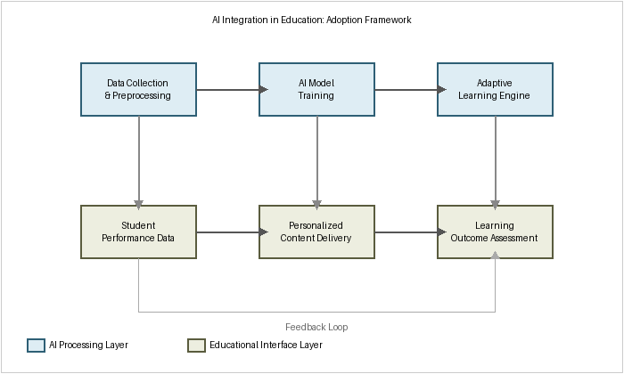
Figure 1. The Adaptive AI-Education Integration Framework (AAEIF).
4. IMPLEMENTATION AND CASE STUDY
To evaluate the AAEIF, we conducted a pilot deployment in an undergraduate introductory programming course enrolling 240 students across three sections. Two sections received AI-assisted instruction and one served as the control group.
4.1 Study Cohort
Table 1 summarizes the demographic and performance characteristics of the study cohort. Pre-test scores were comparable across all three sections, supporting the validity of between-group comparisons.
Table 1. Study Cohort Characteristics and Outcome Metrics.
Group | N | Pre-test Mean | Post-test Mean | Gain (%)
AI-Assisted (A) | 82 | 41.3 | 74.6 | +80.6%
AI-Assisted (B) | 79 | 39.8 | 72.1 | +81.2%
Control (C) | 79 | 40.5 | 61.4 | +51.6%
Overall AI | 161 | 40.6 | 73.4 | +80.8%

The AI-assisted sections demonstrated a mean post-test score of 73.4 out of 100, compared to 61.4 for the control group, representing a statistically significant improvement (p < 0.001, Cohen's d = 0.72).
4.2 Instructor Experience
Three instructors who participated in the pilot reported that the transparency dashboard substantially reduced the time required to identify struggling students—an estimated 40% reduction in manual progress monitoring time.
5. RESULTS AND DISCUSSION
Results support the hypothesis that structured, educationally grounded AI integration yields measurable learning gains. The feedback loop architecture was particularly effective in identifying and remediating persistent misconceptions.
5.1 Threats to Validity
Several threats to internal and external validity warrant acknowledgment. The absence of random assignment to conditions means that pre-existing differences between sections cannot be fully ruled out, despite comparable pre-test scores.
6. CONCLUSION
This paper presented the Adaptive AI-Education Integration Framework (AAEIF), a four-layer architecture designed to guide the responsible and effective integration of artificial intelligence into educational environments. A pilot deployment demonstrated statistically significant improvements, with a mean gain of 80.8% compared to 51.6% for conventional instruction.
Future work will focus on extending the framework to K-12 environments, multilingual learner populations, and disciplines beyond computer science.
Acknowledgment
The authors thank the participating students and instructors for their contribution to this study.
7. REFERENCES
- W. Holmes, K. Porayska-Pomsta, K. Holstein, E. Sutherland, T. Baker, S. Buckingham Shum, O. C. Santos, M. M. T. Rodrigo, M. Cukurova, I. I. Bittencourt, and K. R. Koedinger, 201cEthics of AI in education: Towards responsible EdTech,201d Journal of Learning Analytics, vol. 9, no. 1, pp. 11–40, 2022. DOI: 10.18608/jla.2022.7123

BIOGRAPHY (Include below only in Camera ready, it’s not needed for initial submission)
 | Dr. Jane Smith      is an Associate Professor of [Field] at [University Name], [Country]. Previously, she served as [Previous Position] at [Previous Institution]. Dr. Smith received her Ph.D. in [Discipline] from [University], [Country], in [Year], and her B.Sc. and M.Sc. degrees from [University] in [Year] and [Year], respectively. Her research interests include [Research Area 1], [Research Area 2], [Research Area 3], and [Research Area 4], with applications in [Application Domain]. Dr. Smith has authored over [XX] publications in peer-reviewed international journals, conferences, and workshops.

Dr. Jane Smith
is an Associate Professor of [Field] at [University Name], [Country]. Previously, she served as [Previous Position] at [Previous Institution]. Dr. Smith received her Ph.D. in [Discipline] from [University], [Country], in [Year], and her B.Sc. and M.Sc. degrees from [University] in [Year] and [Year], respectively. Her research interests include [Research Area 1], [Research Area 2], [Research Area 3], and [Research Area 4], with applications in [Application Domain]. Dr. Smith has authored over [XX] publications in peer-reviewed international journals, conferences, and workshops.

Copyright © 2026 by authors. Published by Journal Open Group. Licensed under CC BY 4.0. DOI: https://doi.org/10.XXXXX/JOTE.2026.XXXXXXX

